**PRESS RELEASE**Alliance Française de Chicago   
[810 N Dearborn St  
Chicago, IL 60610](https://goo.gl/maps/H5kCfFtzXCj81ZqH9)  
Elizabeth Wojdyla  
(312) 337-1070  
Email: [ewojdyla@af-chicago.org](mailto:ewojdyla@af-chicago.org) **Event Image Link:** <https://flic.kr/s/aHBqjzQNgn> **FOR IMMEDIATE RELEASE**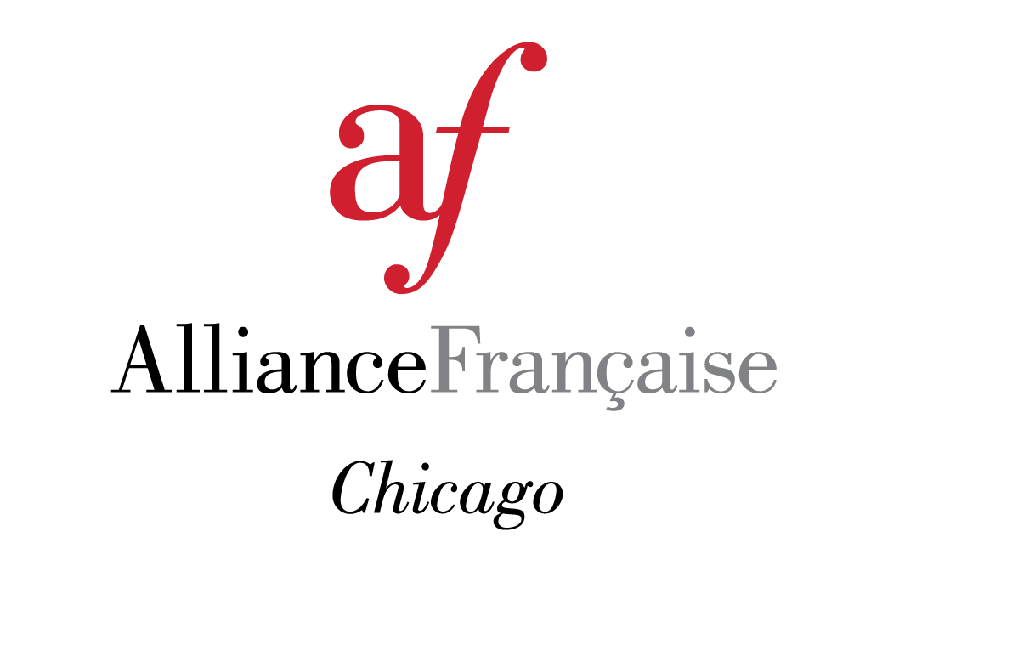

**The Woman’s Board of the Alliance Française de Chicago Exceeds Goal   
at biennial Gala, *125 Le Bal***

**CHICAGO, IL** – The Alliance Française de Chicago Woman’s Board hosted its biennial gala on May 7, 2022 at the Four Seasons Hotel Chicago, named *125 Le Bal* in honor of the organization’s 125th anniversary. This event celebrated the legacy of one of Chicago’s oldest cultural institutions as well as its continued dedication to French education, culture and outreach.   
  
Almost 400 of Chicago’s most influential cultural, civic and social leaders joined prominent members of the French community to raise key operating funds for education, language immersion programs for Chicago Public Schools (CPS) students from core neighborhoods, and cultural offerings at the Alliance, the place for all things French in Chicago.   
  
A parade of fashion ascended the grand staircase for this evening of *élégance française*. Renowned as one of Chicago’s most elegant galas, guests enjoyed innovative entertainment, music and dancing with the John Paris Band, sumptuous French-inspired cuisine and French wines. The evening concluded with a lively afterparty featuring world-renowned DJ Madrid.  
  
Attendees excitedly bid against each other for lavish prizes such as one-of-a-kind international travel opportunities, luxury items, exclusive experiences, and fine wines. This year’s goal was to raise a minimum of $400,000, which was surpassed by raising almost $440,000 due to the generosity of the evening’s guests and the greater Alliance Française community.  
  
“*C’était magnifique!* We couldn’t have asked for a better event and are truly grateful for the support of our community.” said Mary Ellen Connellan, Executive Director of the Alliance Française de Chicago.

Catharine Hamilton, in recognition of her many years of dedication to French culture and the Alliance, was the honorary co-chair. The Prix de l'Alliance Française de Chicago was awarded to long-time champion of the Alliance, Myriam Bransfield who is an ardent advocate of the Alliance Française from championing the creation of a state-of-the-art demonstration kitchen to steering the Symposium on the Arts of France with a keen eye and discerning taste for the last 15 years.   
  
“Our dear Alliance has come very far in these 125 years. We have not only grown in size but also in the great cultural influence the Alliance offers to our dear city. From public school youngsters to sophisticated adult programs this institution offers its warmest welcome to students and guests. Love and pride fill my heart!” said Myriam Bransfield, Prix de l'Alliance Française de Chicago honorée.

The *125 Le Bal* gala co-chairs, Elisabeth Adams and Gail Hoffman, led the 75-member Woman’s Board in the production of this exquisite event. To donate to the continuation of these many enriching programs, visit: <https://myalliance.af-chicago.org/pages/fundraising/2022-125-le-bal>

# # #

The Alliance Française de Chicago is a 125 year old 501(c)(3) non-profit organization that is part of an international network of over 1,100 Alliance cultural centers worldwide. We are Chicago’s center of French language and French-speaking cultures with a mission to promote exchange, understanding, and friendship between Americans and all French-speaking people— a world of over 220 million French speakers on every continent. www.af-chicago.org.